Emerging CARTs in CLL

John G Gribben MD DSc FMedSci
Hamilton Fairley Professor of Medical Oncology Barts Cancer Institute

Rationale for CAR T Cells:
• Despite all the advances in treatment of CLL with novel targeted therapies, patients with multiply relapsed or refractory disease or high risk features have poor prognosis
• Incurable except with allogeneic BMT/SCT
► Associated with extensive morbidity and mortality
► Many patients not eligible (advanced dz, age, comorbidity, etc.)
• Newer, more effective therapies for advanced and high risk CLL are necessary

Commercial CAR T Cell Products in pivotal trials:
KTE-C19 Axicabtagene ciloleucel (KITE) Gentransfer with Retrovirus
CTL-019 Tisagenlecleucel (Novartis) Gentransfer with Lentivirus
JCAR017 (CD4:CD8 = 1 :1) Lisocabtagene maraleucel (Juno Therapeutics/BMS ) Gentransfer with Lentivirus

UPenn - CTL-019 (Tisagenlecleucel) Clinical Responses: Bulky Tumor Eradicated Following CART19 Infusion (NCT01747486)
Long term persistence of CAR-T documented in this cohort

- Porter et al. NEJM, 2011 (& presentation David Porter)
- Katos et al. Sci Trans Med 2011
- Frey, Gill et al, JCO 2020
- Melenhorst JJ et al Nature 2022

The tumor microenvironment:
cancer cells, TAM Tumor­associated macrophages, Tregs, NK-cells, Cytotoxic T cells, APCs

Cancer cells do not live in isolation but in immune rich environments.
The host adaptive and innate immune mechanisms should be able to recognize and kill cancers - but clearly fail to do so.
Cancer cells have usurped physiologic responses in a pathological way to escape immune mediated killing.

T and NK cells from CLL patients have altered gene expression pathways:
GEP studies identified multiple gene defects induced by malignant cells resulting in functionally impaired: - actin polymerization, immune synapse formation, cytotoxicity, motility. cytokine and chemokine production

Loss of Naïve and Expansion of Exhausted Effector Memory T Cells:
Increased expression of KLRG-1 and CTLA-4 on T-and NK cells, LAG-3 mainly on CD4+ T-cells, regulatory T-cell and NK-cells, TIM-3 expression on CD4+ T-cells and Treg-cells, CD244 (2B4) expression on NK-cells - T cells further impacted by previous CLL treatment
Far too simplistic to think of TIL cells as TH2

- Görgün et al J Clin Invest 2005,
- Ramsay, et al J Clin Invest 2008,
- Görgün et al PNAS 2009,
- Ramsay et a Blood 2012,
- Kiai et al JCO 2013,
- Riches et al Blood 2013,
PD-L1 blockade: rejuvenating T cells in CLL:
- McClanahan et al Blood 2015a
- McClanahan et al Blood 2015b
- McClanhan et al Hematologlca 2016

How Do We Improve CAR-T Cell Responses in CLL?
Lower CR and PFS compared to other B cell malignancies with CAR-T and still no approved product
- Intrinsic patient T cells defects T cell exhaustion
- Poor T cell expansion
- Poor persistence
- Poor targeting
Enhance T cell health, targeting, and function prior to manufacturing and after infusion
Combine CTL019 with immune modifiers.
Reverse T cell exhaustion through check point blockade
Alternative sources of CAR cells

lbrutinib enhances CLL response to CTL019 (Fraietta et al. Blood 2016):
• T cells from CLL pts on lbrutinib for 6 - 12 mo compared to baseline exhibit:
- superior proliferative capacity in vitro
- superior survival in vitro
- Reduced PDl expression on CD8+ T cells.
• lbrutinib does not impair CAR gene transfer, T cell expansion or cytotoxic capacity in vitro
lbrutinib enhances CTL019 expansion, results in better CLL killing and increased survival in murine models
lbrutinib plus CTL019 may be synergistic in CLL patients.

Fred Hutchison Cancer Center OS/PFS after CART with lbrutinib (Gauthier, et al. Blood, 2020):
• 4-week ORR 83%, and MRD-neg rate 61%
• 1 Yr OS 86%, PFS 59%
• Higher rates of MRD-neg by IGH sequencing
• Lower CRS rates and cytokine levels

Lisocabtagene maraIeucel (Liso-cel; JGAKU17)
CD19-Directed, Defined Composition, 4-1 BB CAR T Cell Product:
CDS+ and CD4+ CAR+ T cell components are administered separately at equal target doses of CDS+ and CD4+ CAR+ T cells; The defined composition of liso-cel results in:
• Consistent administered COB+ and CD4+ CAR+ T cell dose
• Low variability in the CD8+/CD4+ ratio
Dose and ratio of CD8+ and CD4+ CAR+ T cells may influence the incidence and severity of CRS and neurological events.

TRANSCEND CLL 004 a phase 1/2 in heavily pretreated patients with relapsed or refractory CLL, including patients who have failed both BTKi and venetoclax (Siddiqi et al. Blood 2021)
- ORR was 82% (CR/CRi, 46%; PR, 36%), with 68% (n = 15/22) of patients achieving a rapid response within 30 days
- At 12 months, 50% (n = 11/22) were in response and only 2 of these responders progressed beyond 12 months
- All 7 patients who completed the 24-month study maintained their response
- liso-cel treatment resulted in a high rate of uMRD in this heavily pretreated, high-risk population.

Transcend CLL 004: Phase 1 Cohort of Lisocabtagene Maraleucel (liso-cel) in Combination with Ibrutinib for Patients with Relapsed/Refractory (R/R) Chronic Lymphocytic Leukemia/Small Lymphocytic Lymphoma (CLL/SLL) (Wierda et al., ASH 2020; Abstract 544)
- All responders (n = 18/19) achieved a response by Day 30 after liso-cel
- Among 18 patients with ≥6 months of follow-up, 89% (n = 16/18) maintained or improved response from Day 30
- Of 17 patients who achieved uMRD in blood, all achieved this response by Day 30; only 1 later progressed due to Richter transformation (RT).

Potential Advantages of NK cells over T cells for CAR therapy:
CD19 CAR-NK
• Allogeneic Product
• "Off the shelf”
• Potential low cost
• 1 cord. > 100 doses
• Low/absent GVHD
• CAR+ NK Receptor mediated

CAR T:
• Autologous Product
• Production time
• Cost
• 1 patient, 1 product
• If allogeneic: GVHD Risk
• Toxicity: cytokine release syndrome; neurotoxicity (50% need ICU care)
• CAR-mediated killing

Use of CAR-Transduced Natural Killer Cells in CD19-Positive Lymphoid Tumors
(Liu et al, NEJM 2020) :
Patient 5 Achieved Complete Response in Richter's Transformation (1 x 1 0e6/kg)
CAR NK cells are detectable by qPCR up to 12 months post infusion in majority of patients.

FT596: Multi-Antigen Targeted, Off-the-Shelf, iPSC-Derived CAR NK Cell Therapy
FT596: CAR NK cell therapy manufactured from a clonal master iPSC line uniformly engineered with three anti-tumor modalities:
- hnCD16 and CAR19 provide potent dual-antigen targeting capability against malignant B-cells when combined with mAb to prevent antigen escape
- IL-15 Receptor Fusion promotes cytokine-autonomous persistence
Uniformly engineered CD56+ NK cells with > 95% expression of both hnCD16 and CAR19.
Cryopreserved for off-the-shelf availability allowing consistent administration in multiple doses
- Median study follow-up time for patients treated at 2:90M FT596 cells is 4.2 months
- 10 of 13 responders remain in response at data cutoff between 1.9 and 10.8 months from initiation of treatment.

Recent studies on alloHCT and CARTS in CLL: Outcome comparison:

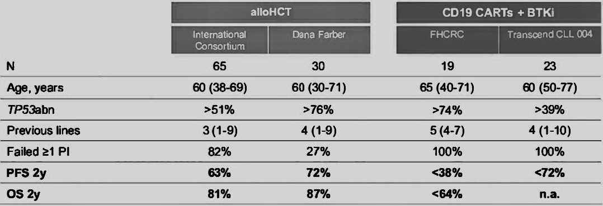
Roeker et al, Blood Adv 2020; Kim et al, Blood Adv 2020; Gauthier et al, Blood 2020; Wierda et al, ICML 2021

Subcutaneous epcoritamab: Preliminary results from the Epcore CLL-1 trial (Kater et at., ASH 2021; abstract 2627):
• These first-reported clinical data for epcoritamab in patients with R/R CLL showed:
- No DLTs at doses up to 48 mg
- Manageable safety profile and no unexpected safety findings
- CRS events occurred early and resolved
- No ICANS or tumor lysis syndrome events
• Preliminary efficacy findings show responses in this heavily pretreated population with high-nsk disease, including
1 CR and 3 PRs
• Further clinical evaluation in CLL and Richter's syndrome is ongoing
• Responses were observed in 4 patients, including 1 CR and 3 PRs
• Responders had high-risk disease; 3 of 4 responders had TP53 aberrations

CONCLUSIONS
• CLL among the first diseases treated with CAR-T, but still no approved product
• CAR-T can overcome the T cell defects seen in this disease and lead in some cases to durable
responses
• Immune modulators to enhance T cell function are being explored and most developed with
lbrutinib
• NK and other cell types being explored

